

Hard Level Programs (16-30)

Date – 120/03/2026

Name: M. Sahasra
Reg. No.: 192425317
Course Code: CSA0919
Course Name: Programming in Java for Spring Framework
Faculty Name: Dr. Magesh Kumar

16. K Weakest Rows in Matrix

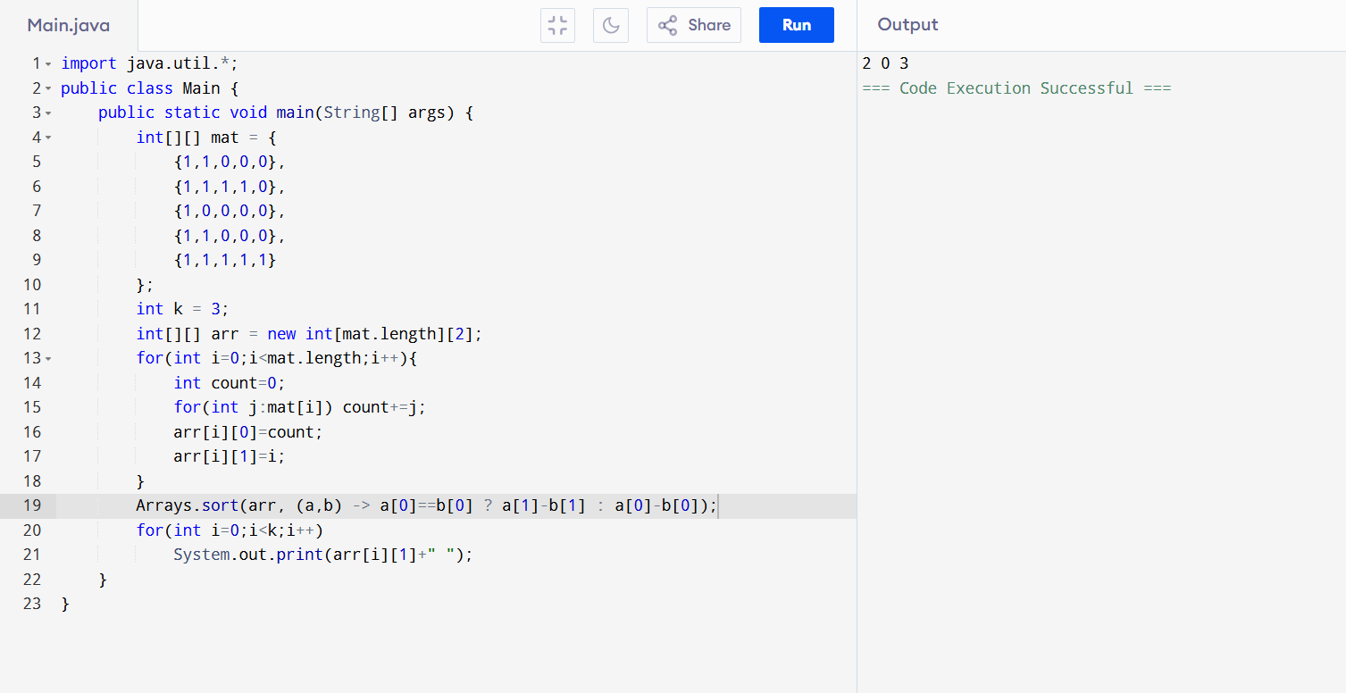

17. Steps to Reduce Number to Zero

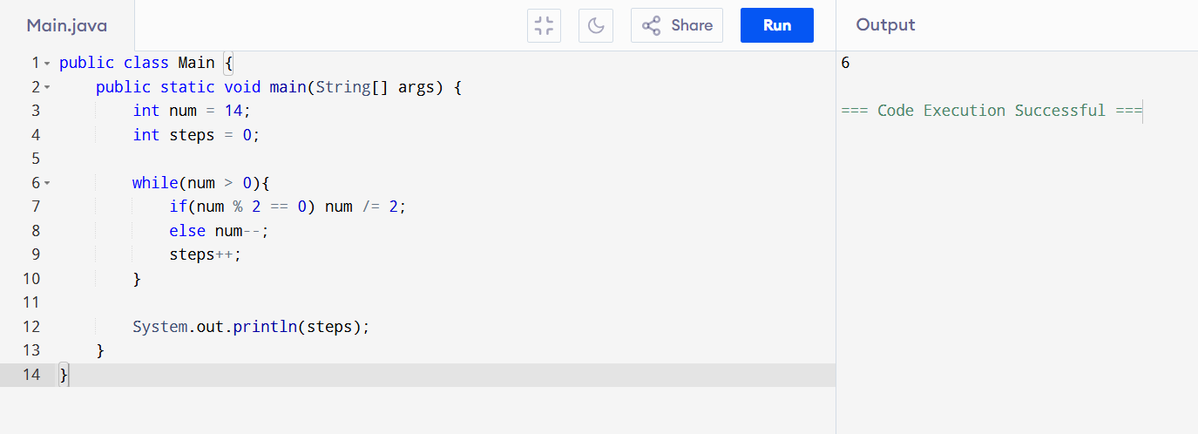

18. Student Grade (Multiple Inheritance via Interface)

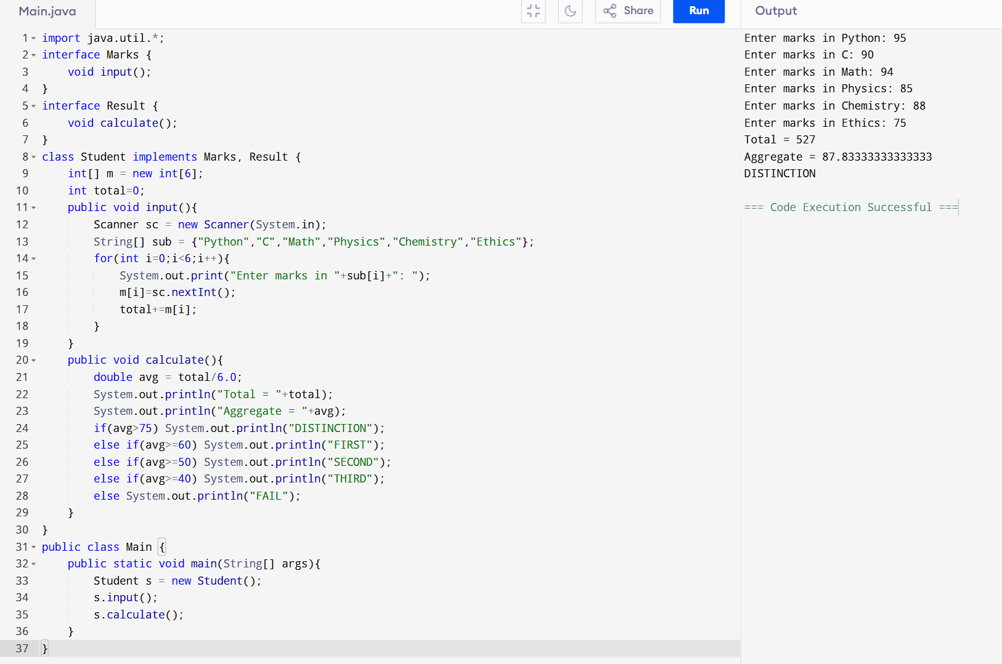

19. Tax Calculation

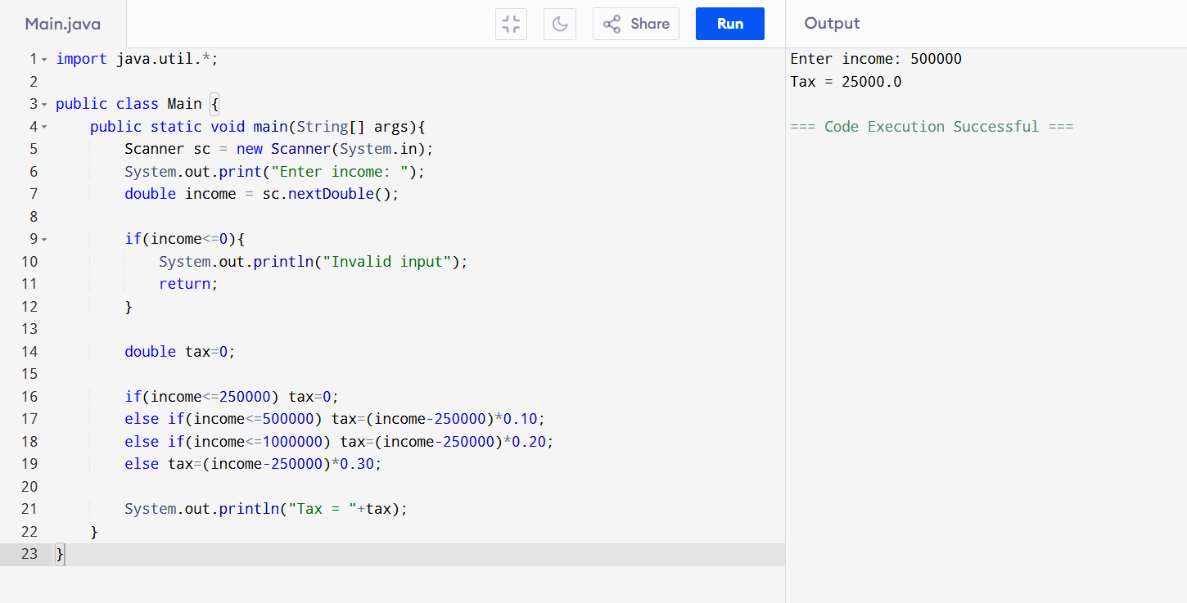

20. Electricity Bill

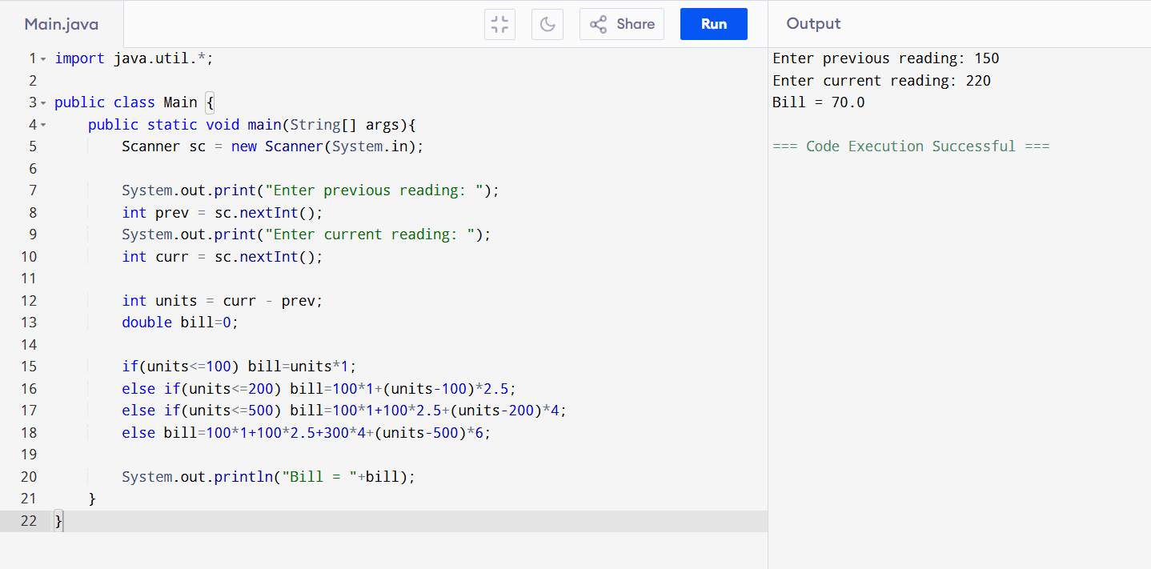

21. Inheritance (Vehicle)
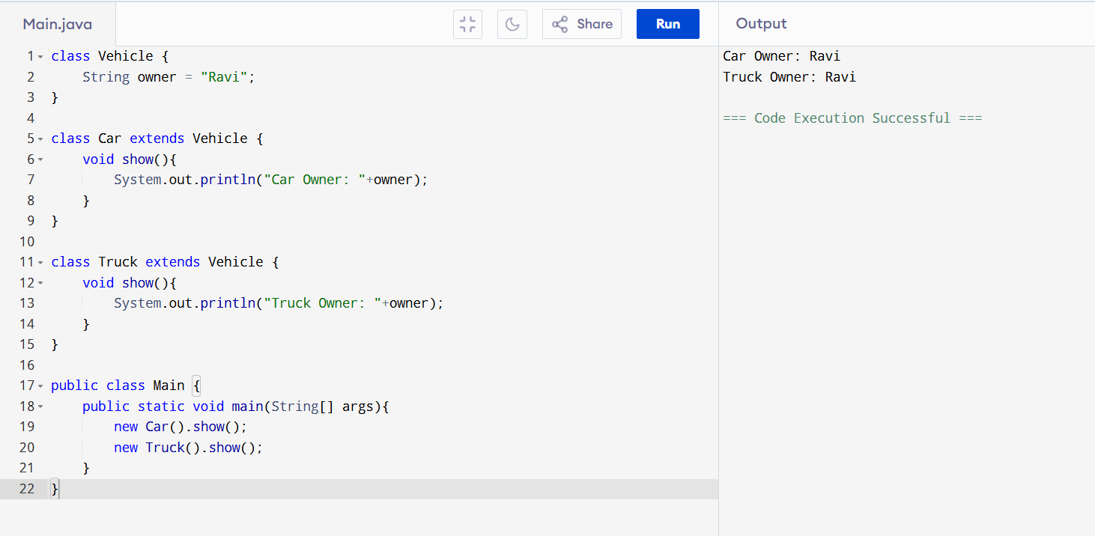
22. Directory Program
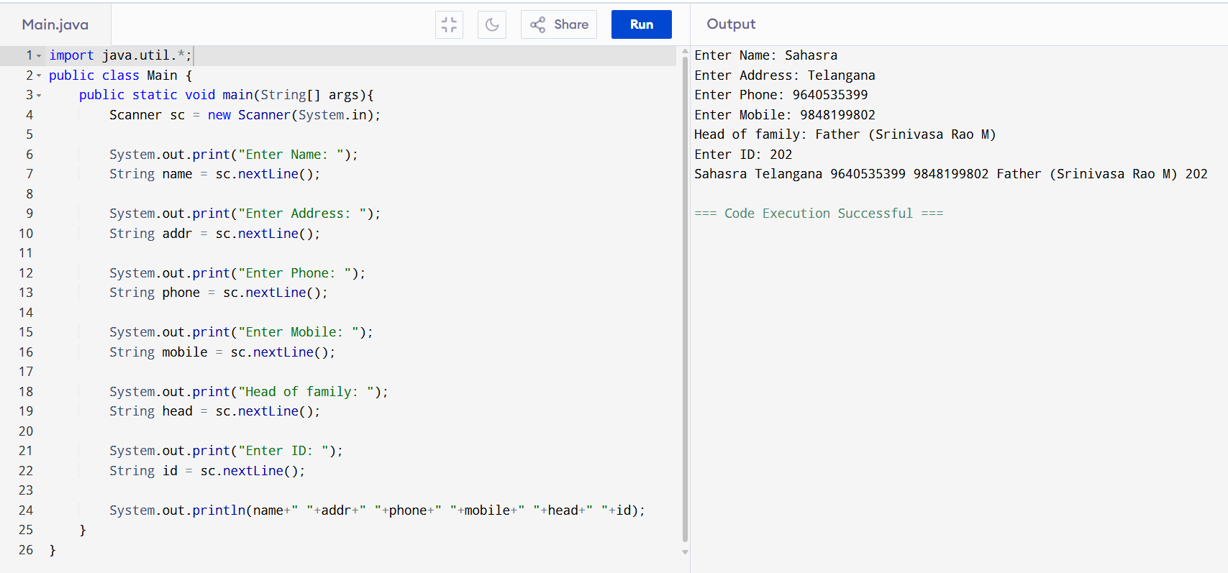
23. Multi-thread Calculator
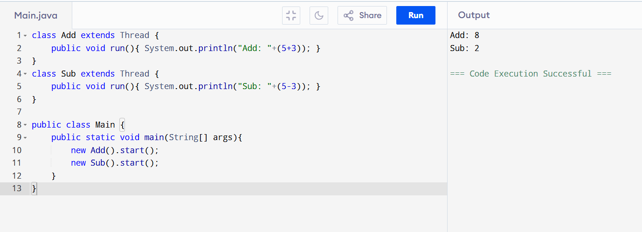
24. Minimum Palindrome Cuts

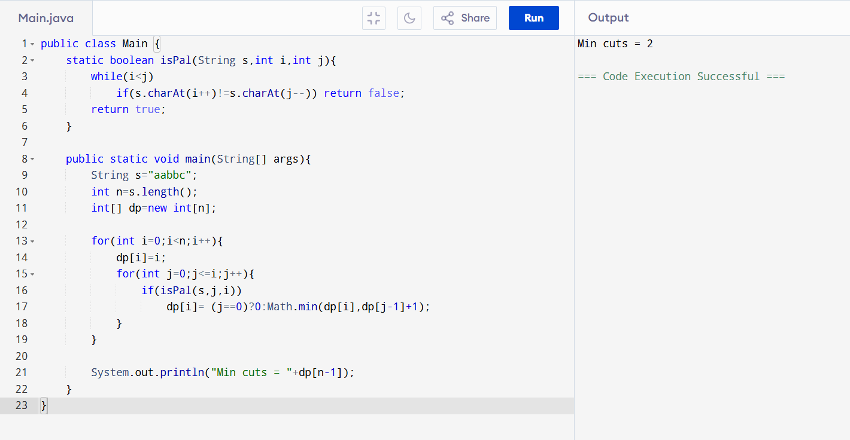

25. Divide Array into 3 Equal Parts

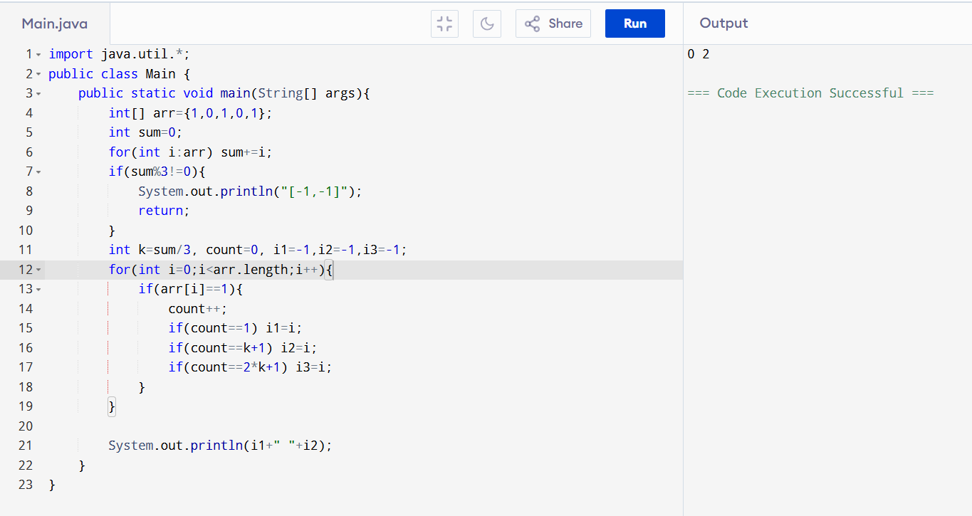

26. Word Filter

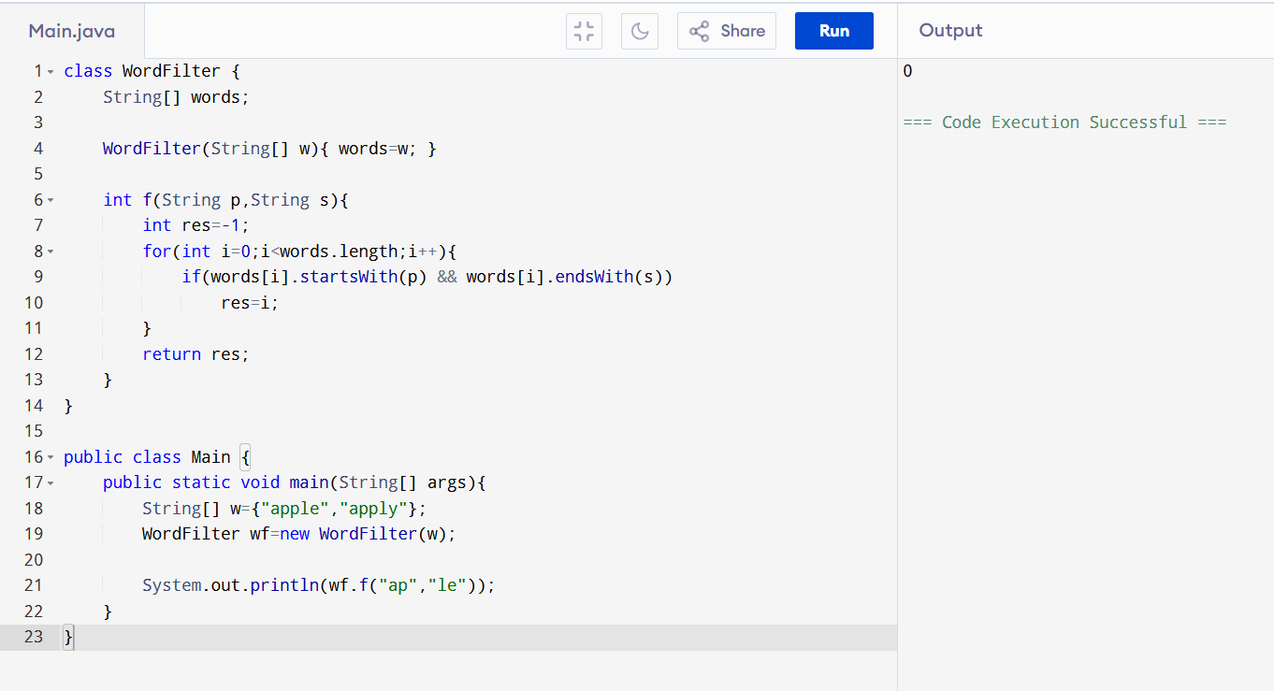

27. NumArray (Update + Sum)

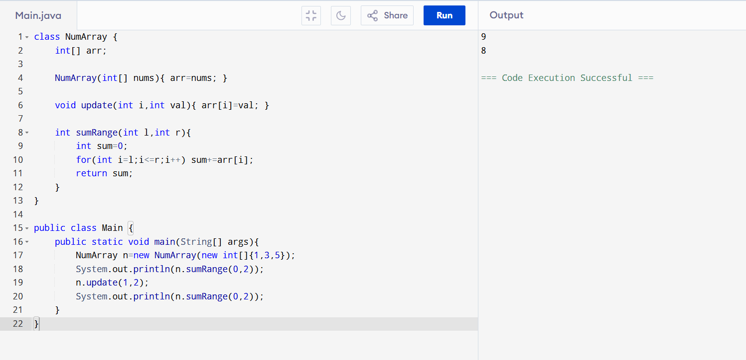

28. Bitwise OR Subarrays

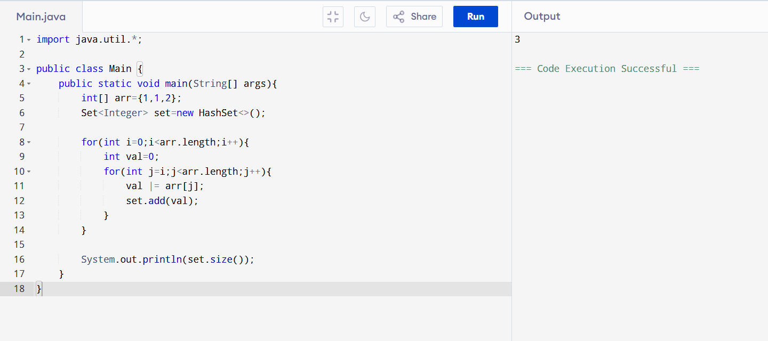

29. Add Base -2

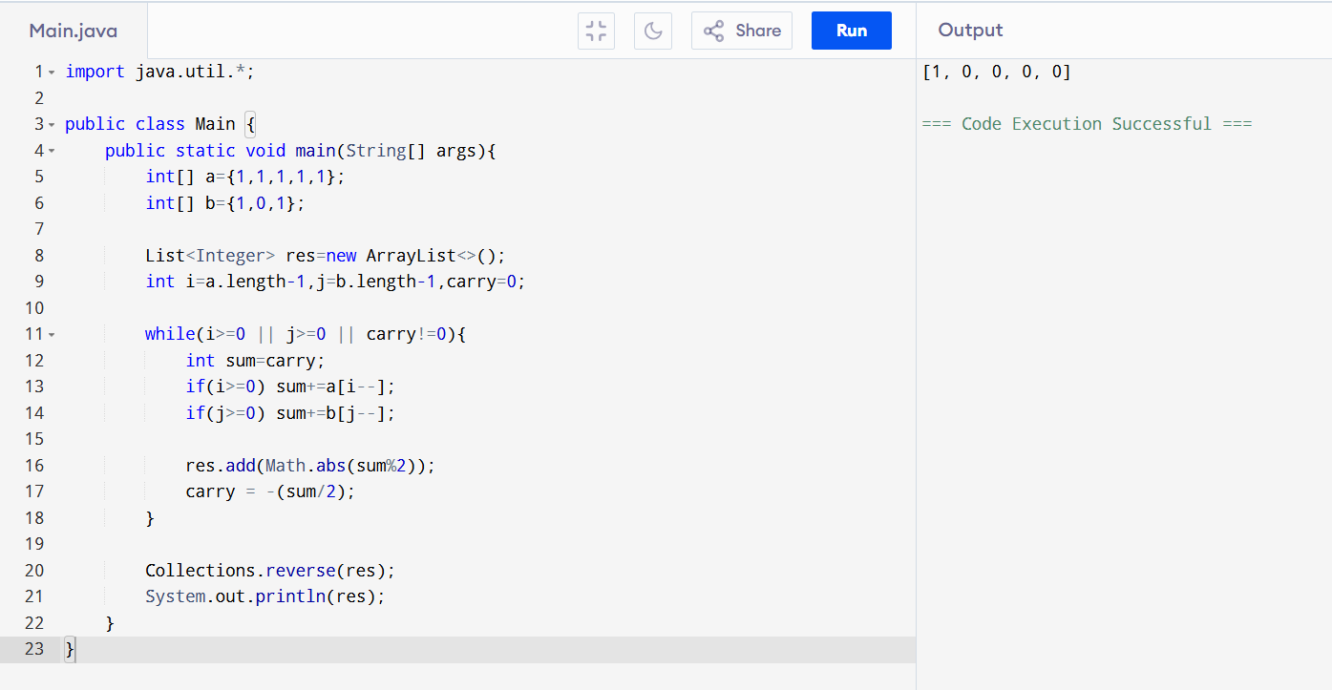

30. Fibonacci Split String
